Given an n x n binary matrix grid, return *the length of the shortest****clear path****in the matrix*. If there is no clear path, return -1.

A **clear path** in a binary matrix is a path from the **top-left** cell (i.e., (0, 0)) to the **bottom-right** cell (i.e., (n - 1, n - 1)) such that:

* All the visited cells of the path are 0.
* All the adjacent cells of the path are **8-directionally** connected (i.e., they are different and they share an edge or a corner).

The **length of a clear path** is the number of visited cells of this path.

**Example 1:**

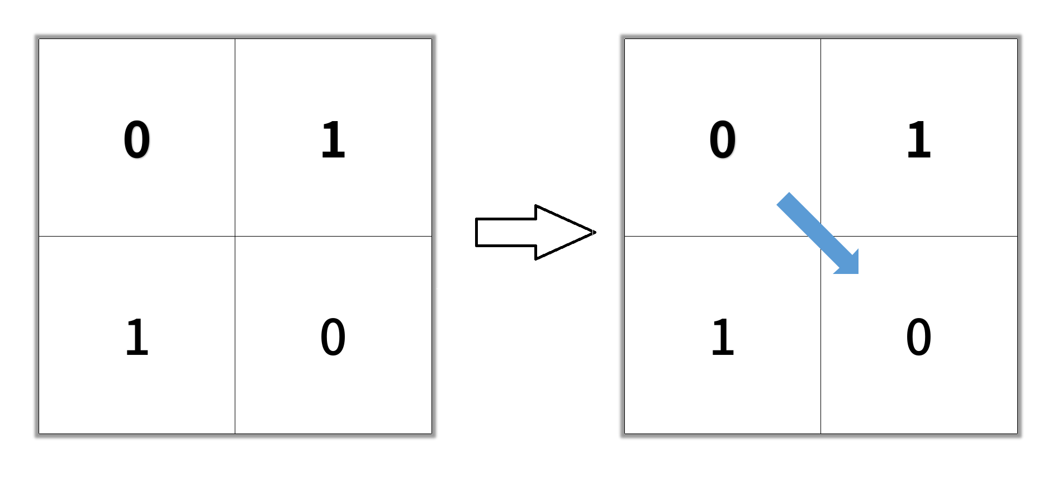

**Input:** grid = [[0,1],[1,0]]

**Output:** 2

**Example 2:**

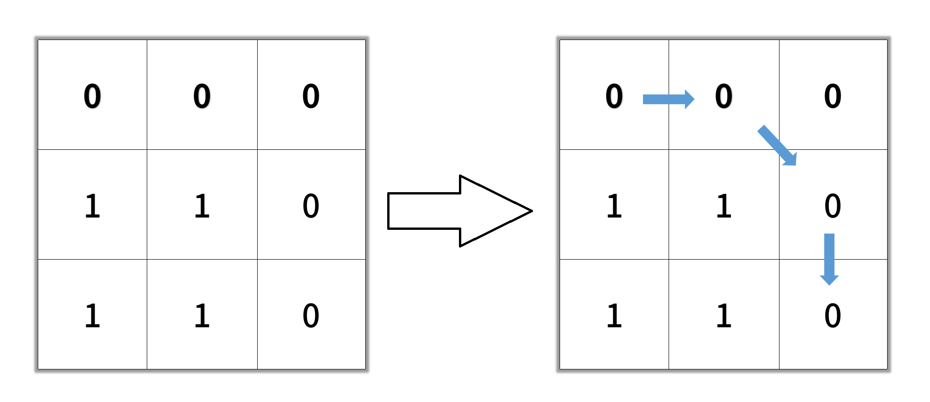

**Input:** grid = [[0,0,0],[1,1,0],[1,1,0]]

**Output:** 4

**Example 3:**

**Input:** grid = [[1,0,0],[1,1,0],[1,1,0]]

**Output:** -1

**Constraints:**

* n == grid.length
* n == grid[i].length
* 1 <= n <= 100
* grid[i][j] is 0 or 1